**Notice on Plagiarism**

|  |
| --- |
| Plagiarism occurs if you copy any part of a source and then submit it, claiming that it is your own work. Such items could include, but not limited to:   * Text (reflection journals) * Image (including photograph, drawing, screenshots) * Computer program / code * Answers to online quiz questions   All work that you submit **must be your own**. You cannot gain credit from the hard work of others.  **Note on computer programs:**  Almost all computer programs contain many ideas borrowed from elsewhere. Many also contain short sections of actual code copied from elsewhere. For example, as you will see in this module, some of the code in the file startup.cs and other files are completed by simply copying a few lines of code from sample code provided in the project setup guide document (with or without minor changes). These activities (setting up code for your files based on the guide given), plus copying and modification of code from any learning materials in the module are ok, with certain degree of acknowledgement.  Code and lesson related discussion between you, your classmates, and your lecturer are acceptable and even encouraged. **What you MUST NOT DO is to copy someone else’s code and submit it as your own.** |

Lesson 12

RPNotes – Student Note Taking Web App (Part 5)





To continue enhancing the **RPNotes** prototype, you started to focus on smart technology. To make the app smarter and more useful, the following features are to be implemented:

1. Upload and download attachments for each lesson note. (Appendix A-C)
2. Use Azure speech-to-text service to transcribe sound file. (Appendix D)

Partial code is given. Complete the prototype.

# Appendix A

## Attachment

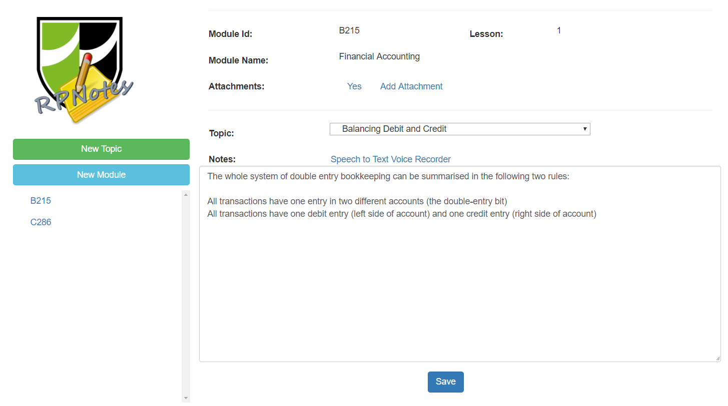

Figure 1 – Lesson note with attachment

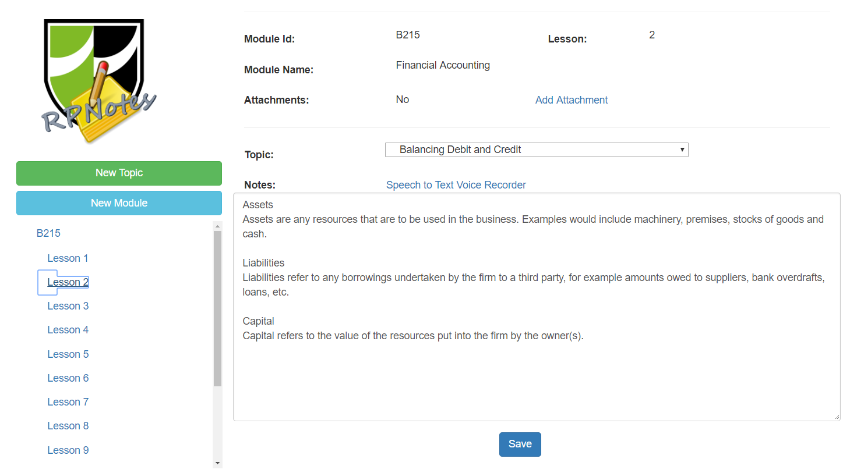

Figure 2 – Lesson note with no attachment

# Appendix B

## Upload Attachment

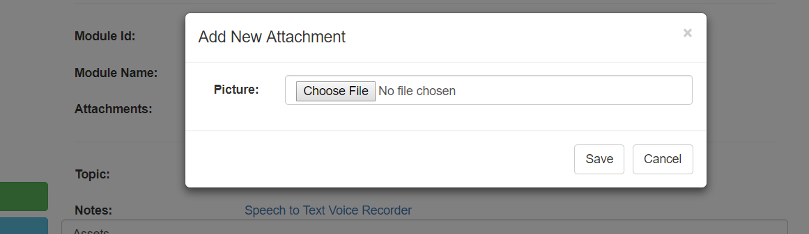

Figure 3 – Choose attachment after clicking on the **Add Attachment** link

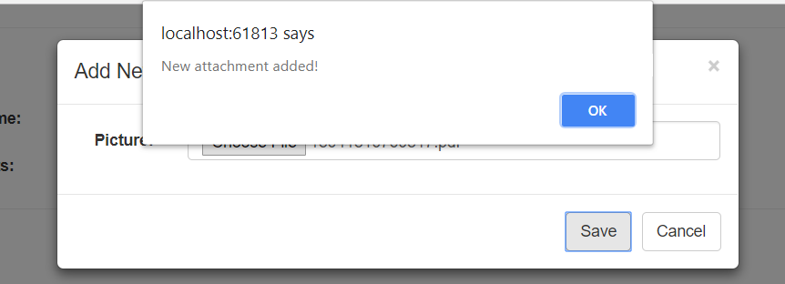

Figure 4 – Upload attachment successful

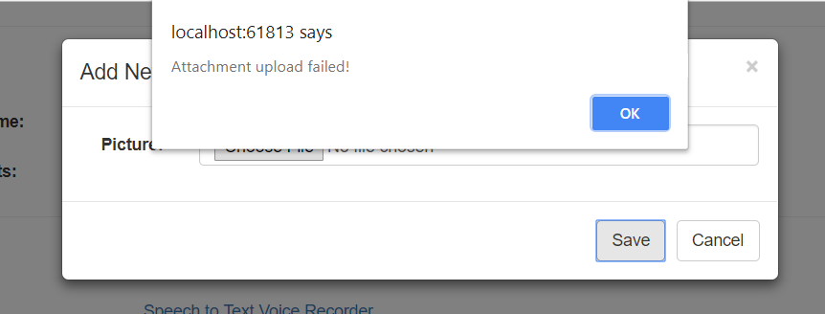

Figure 5 – Upload attachment failed

# Appendix C

## Download attachments

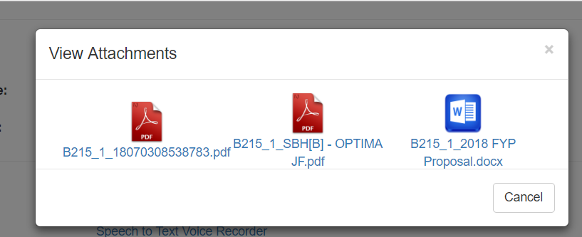

Figure 6 – All attachments are shown when the **Yes** link is clicked

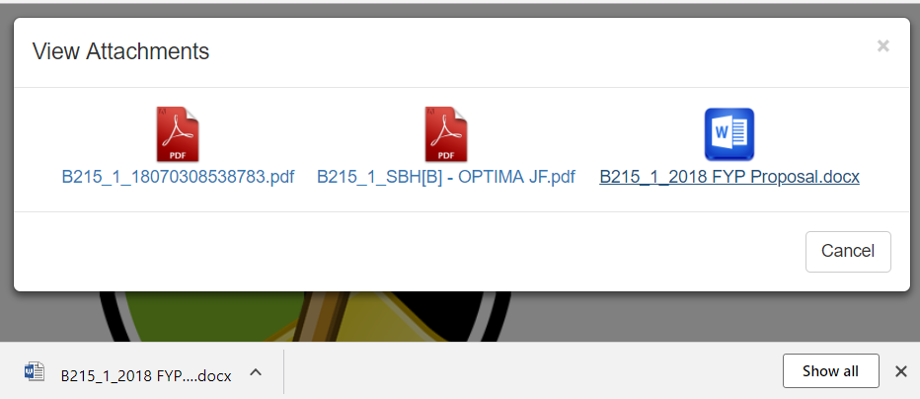

Figure 7 – Attachment can be downloaded one by one

# Appendix D

## Transcribe Sound File

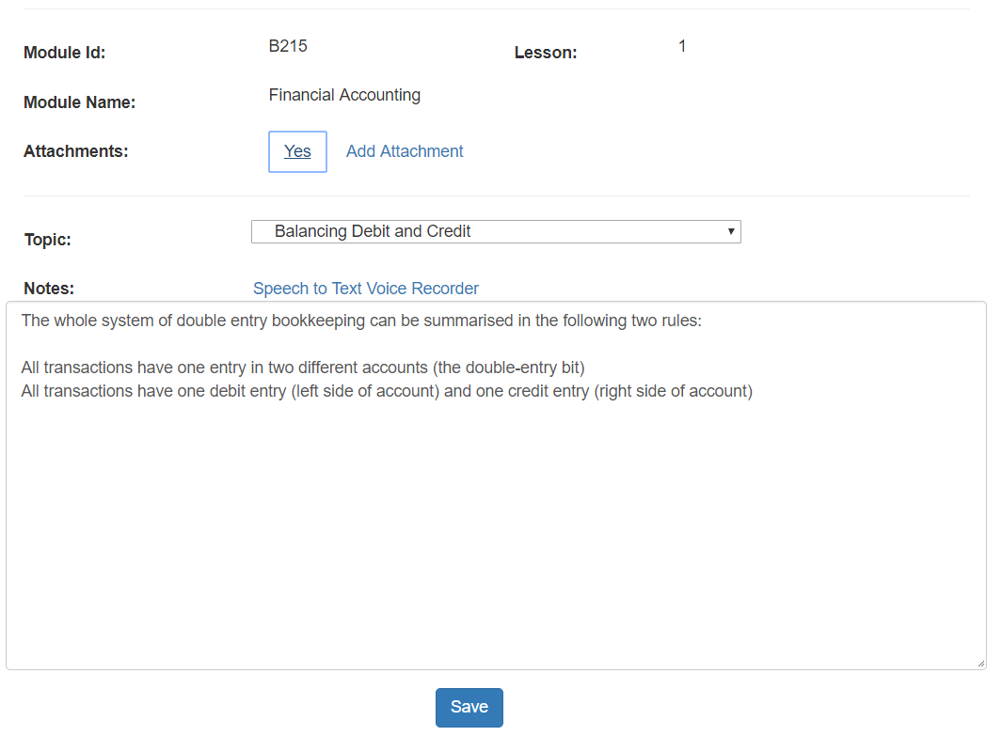

Figure 8 – Links to a simpe voice recorder and transcribe sound file is provided

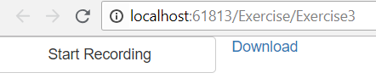

Figure 9 – Simple Voice Recorder

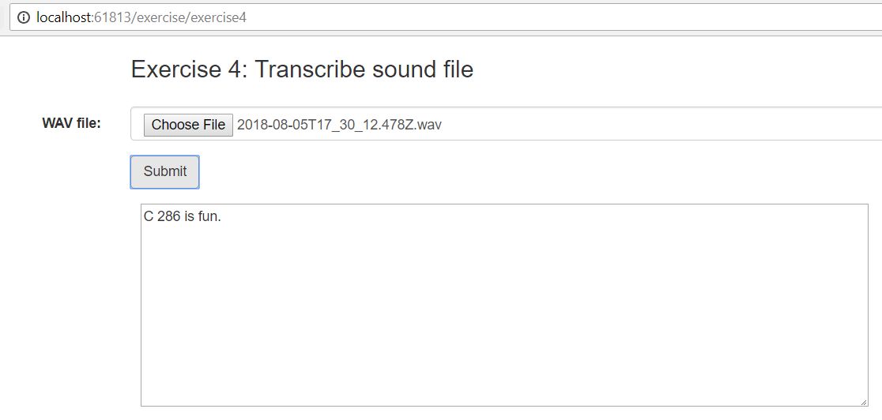

Figure 10 – Sound file transcriber using Asure Speech-to-text service

# Appendix E – Advanced Task (must be done using AJAX, only attempt if you have completed the Problem Statement)

Allow user to delete attachment:

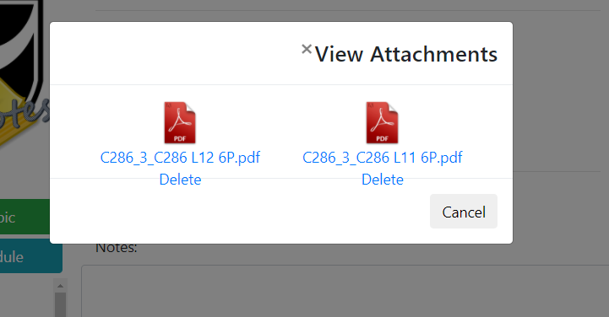

Figure 11 – Provides a link for user to delete a specific attachment

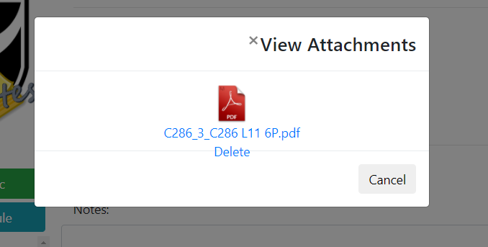

Figure 12 – Reload the attachments after deletion

Helpful Resource:

1. Calling javascript using href attribute：

<https://www.w3schools.com/tags/att_a_href.asp>

